**Depths Charge:**Game Design Brief

**Concept:**

A 2D pixel-based platformer with RPG elements and a time system where time advances depending on your actions. You upgrade your skills by spending time on certain actions (e.g. exercising) before deciding whether you want to enter the “Depths”. In the Depths you will find weapons, magical tomes, and monsters to fight or fall before.

**Gameplay:**

At the start of the game, the player is introduced to the mechanics of the training system at the camp by a traveller before he gets taken away by a monster into the Depths. The player is given 3 months to save him before he perishes.

The Player may use the training equipment around to increase their skill level depending on which equipment the player uses (which will cost time) before entering the Depths.

The Depths has a variety of gameplay “challenges” to test each of the skills. To that end, if there is a skill that the player feels that they are not proficient in, they can always leave the depths and train that skill.

**Core Mechanics:**   
 Time system where doing actions costs time  
 - Doing an activity costs a 1/3 of a day  
 - Going into the depths and leaving at any point costs 1 day  
 - Getting defeated in the Dungeon will cost 3 days  
5 Different training equipment to train your skills, costing  
 - Vitality – Increases the HP Stat  
 - Strength -   
 - Speed  
 - Jump  
 - Magic (Optional) – Increases Damage/Spell Efficiency  
Sword Play  
Spell Play (Optional).  
 - Projectile based spells  
Basic movement with WASD

**Minor Mechanics/Logic:**

A menu to show skills.  
The ability to move from one scene to the next.  
Very Simple Enemy AI.

Hud to show Health, Mana, and the equipped item.

**Out of scope mechanics:**   
Main menu.  
Options menu.  
Different weapon types.  
Treasure that have various passive effects.  
Procedurally generated levels with procedurally generated enemies.  
Minigames for each skill, increasing the skill more for doing better in them.  
**Inspirations/similar works:**   
Persona 5 Royal:

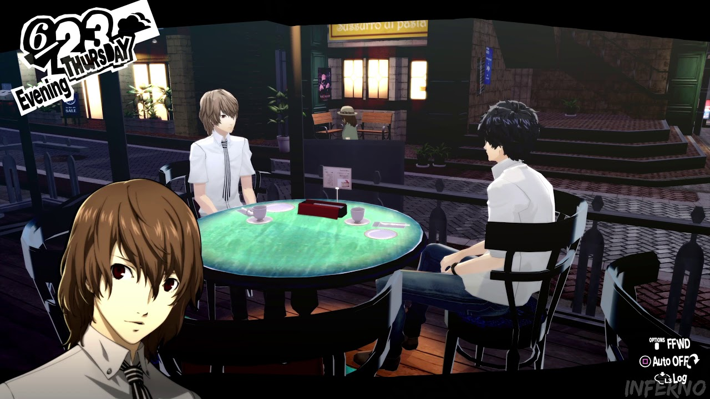  
Bloodstained: Ritual of the Night:  
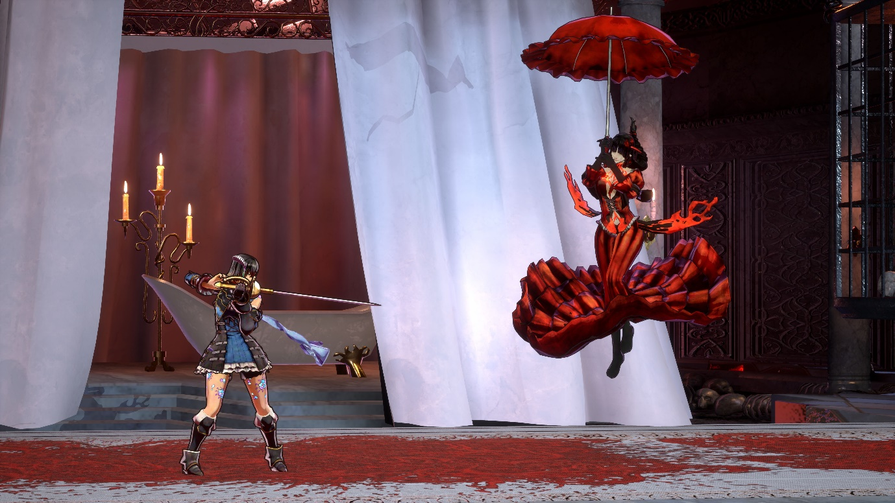

Super Metroid:  
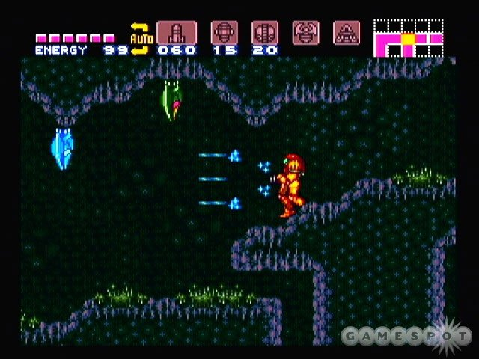  
  
**Development challenges:**

I have yet to learn about HUDs in Unity.  
The game seems difficult to balance, although adjustable

Assets for this will take some time to make.   
**References:**

*Persona 5 Royal* 2020, online picture, Youtube, viewed 16 July 2020,  
<<https://www.youtube.com/watch?v=FdLgyv7Zmaw>>  
*Bloodstained: Ritual of the night Screenshot* 2017, online picture, Nintendo Life, viewed 16 July 2020,<<https://www.nintendolife.com/news/2017/06/505_games_unleashes_new_bloodstained_ritual_of_the_night_e3_2017_trailer>> *Super Metroid* n.d. , online picture, Amazon, viewed 16 July 2020,<<https://images-eu.ssl-images-amazon.com/images/G/02/uk-videogames/2014/ConsoleComp/aplus/SNES_SuperMetroid_lg._V344015694_.jpg>>

[Bellow are the other ideas that were pitched]

**W.G.M.S:**Game Design Brief

**Concept:**

This is First Person Shooter, competitive multiplayer game where players duke it out in space themed arenas, using weapons that are very unusual to win with the most points under a time limit.

**Gameplay:**

Players start the game by choosing a character to play. Once the players choose a character, they spawn into an arena, of which the spawn points are determined by distance and randomness.

Players must force opponent’s health to 0 while making sure they stay alive in the process. Whenever a player does kill an opponent, they score a point to their Kill Score.   
  
After a set about of time, the player with the highest Kill Score wins.

**Core Mechanics:**   
At least 2 Player Online/ Local Split Screen Multiplayer  
At least 2 Different Characters with different items  
A “Reverse Grenade” (Inverts velocity within the explosion range).  
A saw the runs on the ground and at a press of a button, swaps places with the player.  
Ray-Tracing based guns that can push the player away from a surface if they shoot close enough to it  
 - For instance, shooting it at the ground will make the player do a “Jump”.  
Movement with WASD/Arrow Keys

**Minor Mechanics/Logic:**

Character Selection menu.  
Heads up display (HUD) for the following:  
 -Health.  
 -Ammo.  
 -Current Weapon.  
 -Round Timer.  
 -Kill counter for the players in both first and last place, as well as your current kill counter.  
Low Gravity Volumes.  
First person camera that uses the mouse to move it.  
Earning points for every kill.  
Respawn Points.  
 - These Respawn Points are also the points where players start at.  
When Timer ends, announce the winner!  
A countdown timer for the game to start.  
Jump Pads

**Out of scope mechanics:**   
Multiple game modes.  
Main Menu.  
Options Menu with the ability to switch characters.  
Custom characters.  
Skin system for weapons and the like.  
Scoreboard for the round.  
Jetpack.

**Inspirations/similar works:**

Team Fortress 2: Asteroid  
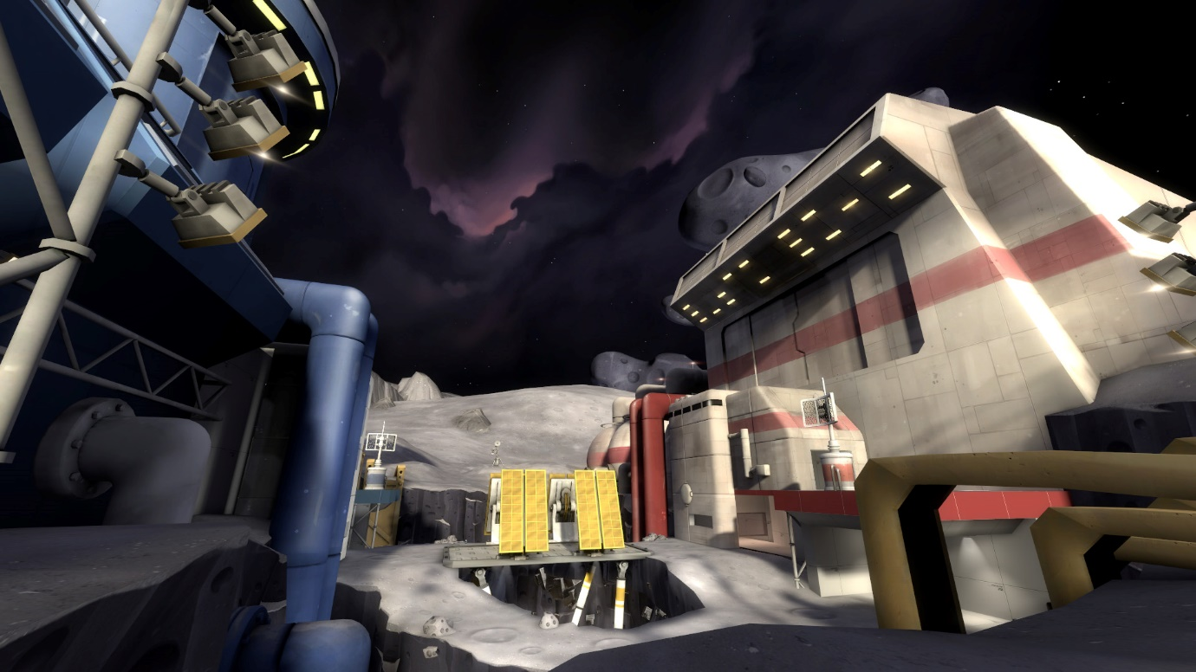  
Borderlands The Pre-Sequel:  
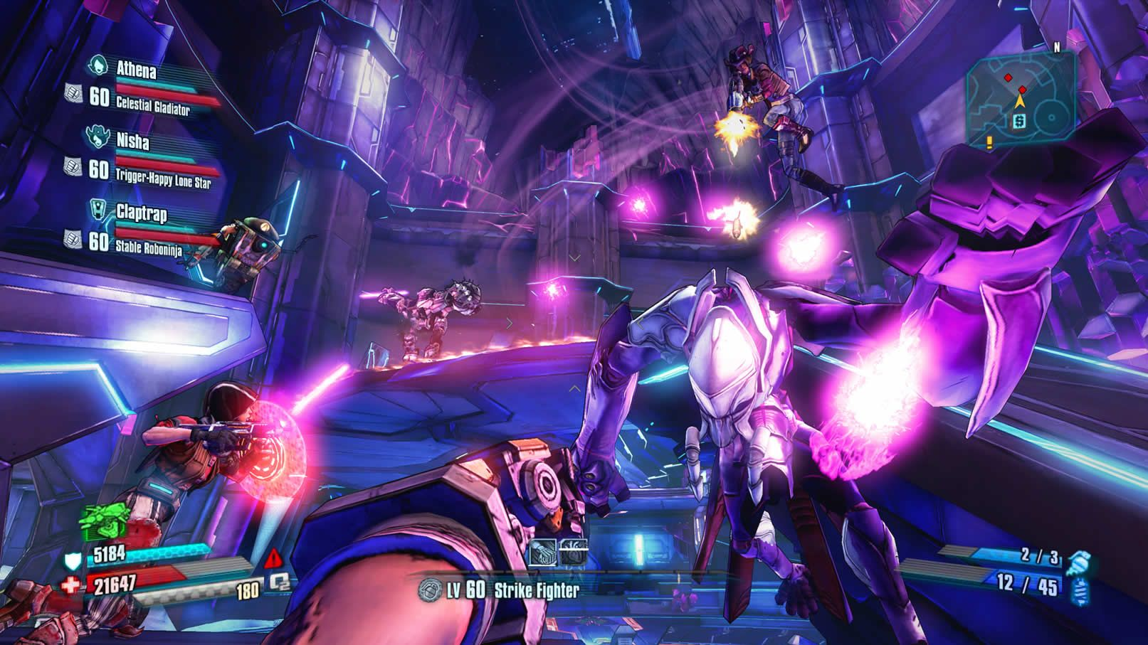  
  
  
  
**Development challenges:**

I do not have the assets for the project yet. (Maybe available in the marketplace but with some restrictions to style). Could set up temp objects to do the job if need be.  
I have yet to learn about HUDs in Unity.  
The game itself is intended to be re-playable, but with every character added. Balancing is to be considered.  
  
**References:**

*Asteroid* n.d., online picture, TF2 Maps, viewed 16 July 2020,  
<<https://tf2maps.net/threads/resource-tf2-theme-inspiration.25317/>>

*Borderlands the Pre-Sequel* n.d., online picture, Megagames, viewed 16 July 2020,  
< <https://megagames.com/sites/default/files/game-images/Borderlands%20The%20Handsome%20Collection%204.jpg>>

**The Magical Brawl:**Game Design Brief

**Concept:**

The Magical Brawl is a top-down auto-chess like game where multiple players verse each other in rounds of fights that span 30 seconds, using spells that have various effects. Before each fight, players will have the opportunity to buy magical spells as well as upgrade ones that they already have.

**Gameplay:**

Each Player starts with 1 Gem to spend on spells, 1 Spell Slot to be able to use a spell, 8 slots to hold spells for later and 3 spells to buy in front of them. The Players have a limited to decide which spell to take, if any, before getting into the first round with a random player. This will be called the “Buying Phase”.

When a fight starts (Fighting Phase), each player will enter a circular arena, with another player with them and stand on opposite sides. Players have 30s to deal as much damage to the opponent as possible before the fight ends. Whomever did the most damage will restore their life back to the health they last had at the start of the fight. Draws heal both players to halfway from their current health to their pre-fight health.

After each fight, players come back to the buying phase with more gems to spend on more spells or upgrading the shop to get another spell slot and access to more powerful spells.  
When the player buys 3 of the same spells, the player may combine them to create a more powerful version of the spell.

The Cycle of phases keeps going until only one player remains, from all other players being defeated.

**Core Mechanics:**   
[Buying Phase]  
8 Players (7 of which can be bots for the purpose of this assessment) online multiplayer.  
A money system (gems) where each turn, more gems are collected.

A buying system to buy spells using mouse clicking to do so  
[Fighting Phase]  
WASD/Arrow key movement  
Mouse movement to have players look at that direction.  
Ability to case spells

**Minor Mechanics/Logic:**

Heath.  
Cooldowns for spells (Different for each spell).  
A base spell class that can make more spells.  
An Arena that will shrink in size the more rounds of Fighting Phases happen.

Win streak Counter.

Players healing health when they win/draw.  
Timer for turns.  
Randomiser for spells.

**Out of scope mechanics:**   
Triple spells also allowing the ability to combine it with another spell to have the two cast at the same time.

Procedurally generated arenas.  
Unique playable characters, giving bonuses to spell types.

**Inspirations/similar works:**   
Hearthstone Battlegrounds Mode:  
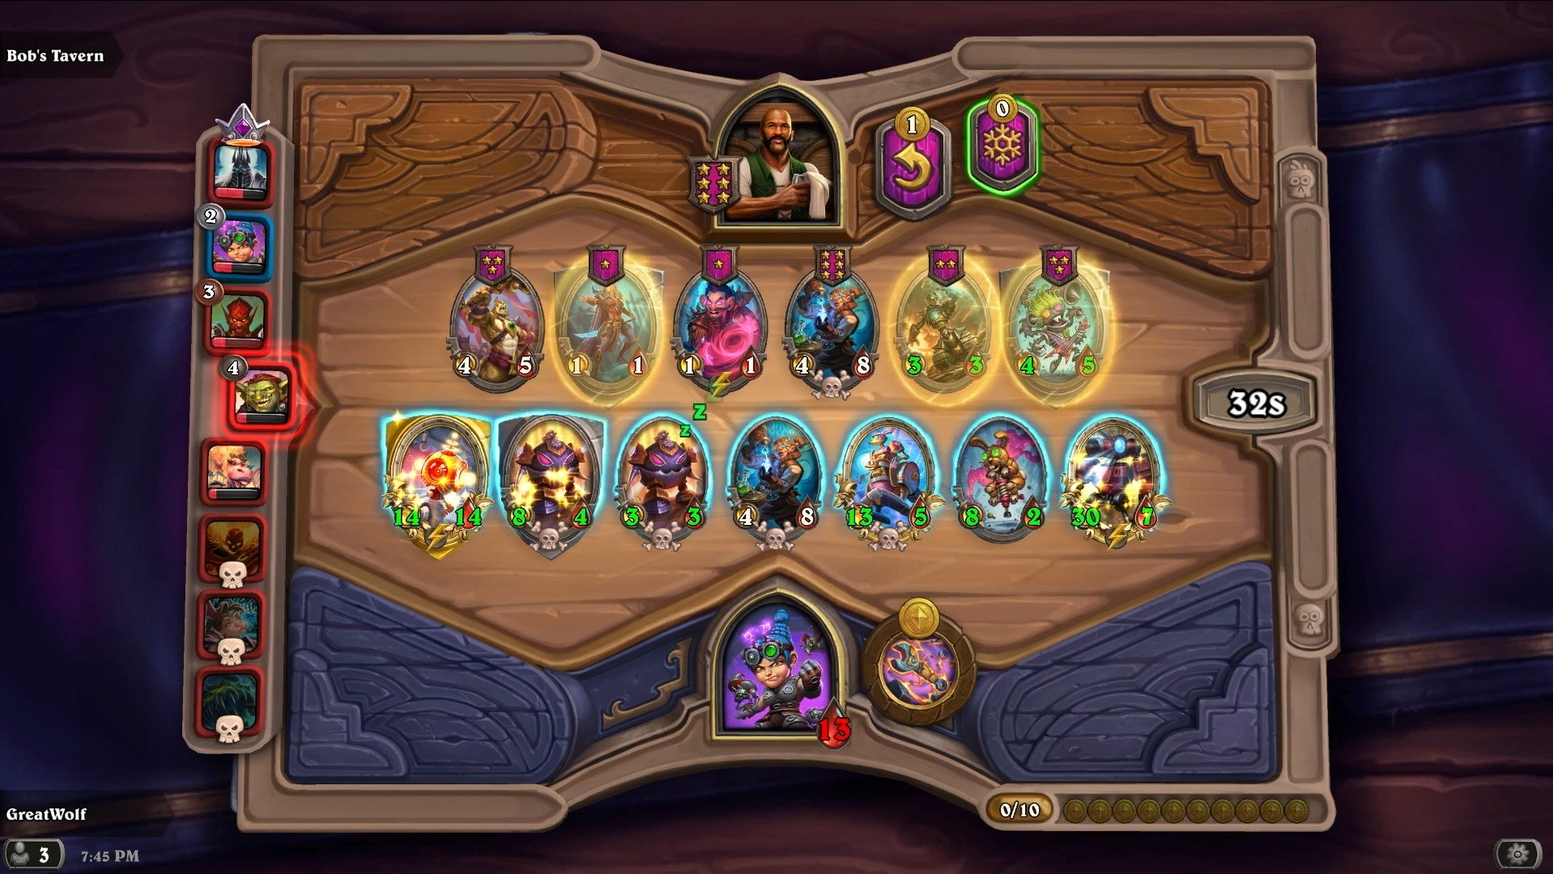  
Battlerite:  
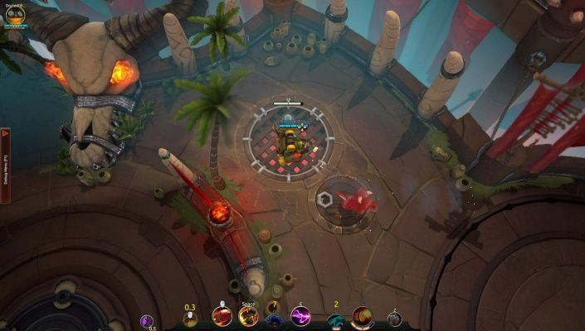

**Development challenges:**

I have yet to learn about HUD’s in Unity.  
This would be the hardest project to get done, lots of code to consider.  
I have assets for spells but not for characters yet.

**References:**

*Hearthstone Battlegrounds* 2019, online picture, Kotaku, viewed 16 July 2020,  
< <https://www.kotaku.com.au/2019/11/hearthstone-battlegrounds-preview-blizzcon-2019-ios-android-pc/>>

*Battlerite* n.d., online picture, Pinterest, viewed 16 July 2020,  
< <https://www.pinterest.com.au/pin/105834659977252771/>>